CALL FOR PAPERS
SPORT LITERATURE ASSOCIATION

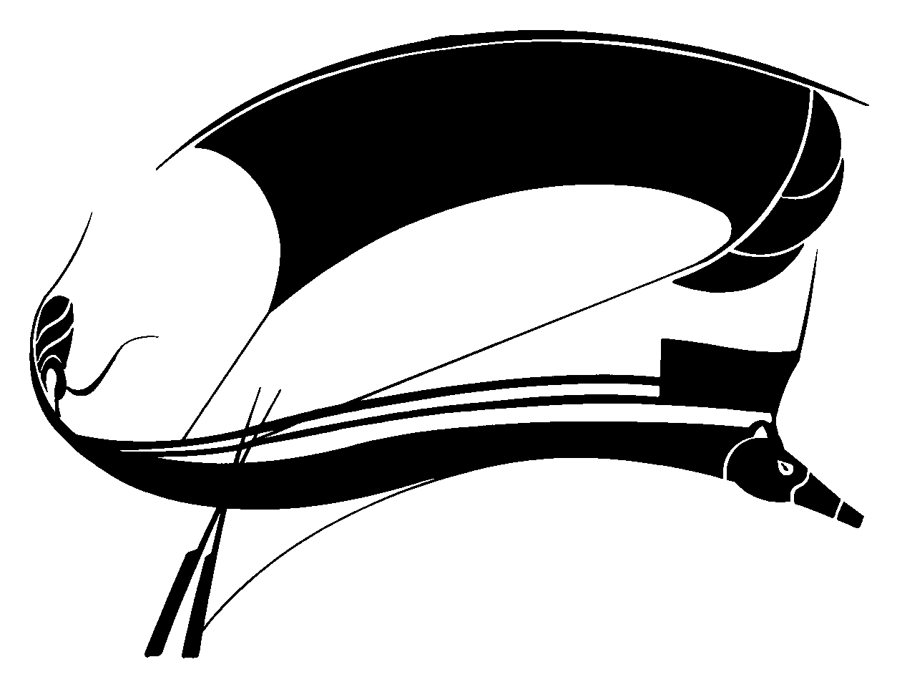

June 19-22, 2019
University of Limoges (Nouvelle-Aquitaine)
FRANCE

Host: Thomas Bauer

Abstract Deadline: March 31, 2019

The 36th Annual Conference of the Sport Literature Association will be held Wednesday, June 19 through Saturday, June 22, 2019, at University of Limoges (France). Limoges is located in the Middle West of France about 135 miles northeast of Bordeaux.

The Program Committee of the Sport Literature Association (SLA) invites proposals for individual papers and/or complete panels related to the literature of sport.

Scholarly and critical submissions for the conference should follow general guidelines set forth in the association's publication, Aethlon: The Journal of Sport Literature, which “celebrate[s] the intersection of literature with the world of play, games, and sport.” Submissions “should address treatments of sport in texts or textual media (print, film, performance, digital or other media).” We invite essays on sport literature (fiction, nonfiction, poetry, drama, or film) or on the rhetoric of sport. Cultural-studies approaches to sport texts are welcome. We also encourage sessions featuring presenters’ original fiction, creative nonfiction, and poetry. Original prose and poetry may be presented in a regular panel or during an evening readings session.

The association welcomes papers from younger scholars and graduate students. Small travel stipends may be available for the latter. Graduate students also may submit essays for the Lyle Olsen Graduate Student Essay Contest (see separate announcement).

Those interested in presenting should send abstracts of individual papers or original work or proposals for complete panels by March 31, 2019, to the program chair Fred Mason (fmason@unb.ca) and copy to the host Thomas Bauer (thomas.bauer@unilim.fr).

Submissions must include presenter’s name, phone number, postal and email addresses, paper title, and a 250-word abstract (Abstracts are published in post-conference proceedings. However, abstracts will be included in the proceedings only for authors who attend the conference and present their material). Indicate the type of presentation as critical study, fiction, creative nonfiction, or poetry. Please indicate any requests for technology (Power Point, Video/Audio Clips, etc.). Individual proposals may, but are not required to, include suggestions for possible panel placement. Presentations should be in english and not exceed 20 minutes.

